Ideation Phase
Empathize & Discover

Date | 31 January 2025
Team ID | LTVIP2026TMIDS66355
Project Name | Laptop Request Catalog Item
Maximum Marks | 4 Marks

Empathy Map Canvas Laptop Required Catalog Item:
An empathy map canvas is a simple visual tool used to understand the behaviors, needs, and experiences of users requesting laptops through a catalog item. It helps teams analyze how employees or managers submit laptop requests, track approvals, and manage device requirements.
By considering what users think, feel, say, and do, teams can identify challenges such as delays in approvals, unclear request details, or tracking request status. This understanding helps in designing a more user-friendly, efficient, and reliable laptop request process that meets user needs and improves overall productivity.
Example:
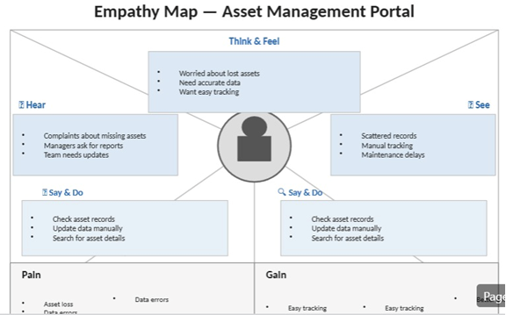
Reference: https://www.mural.co/templates/empathy-map-canvas

Example: Asset Management Portal Application
